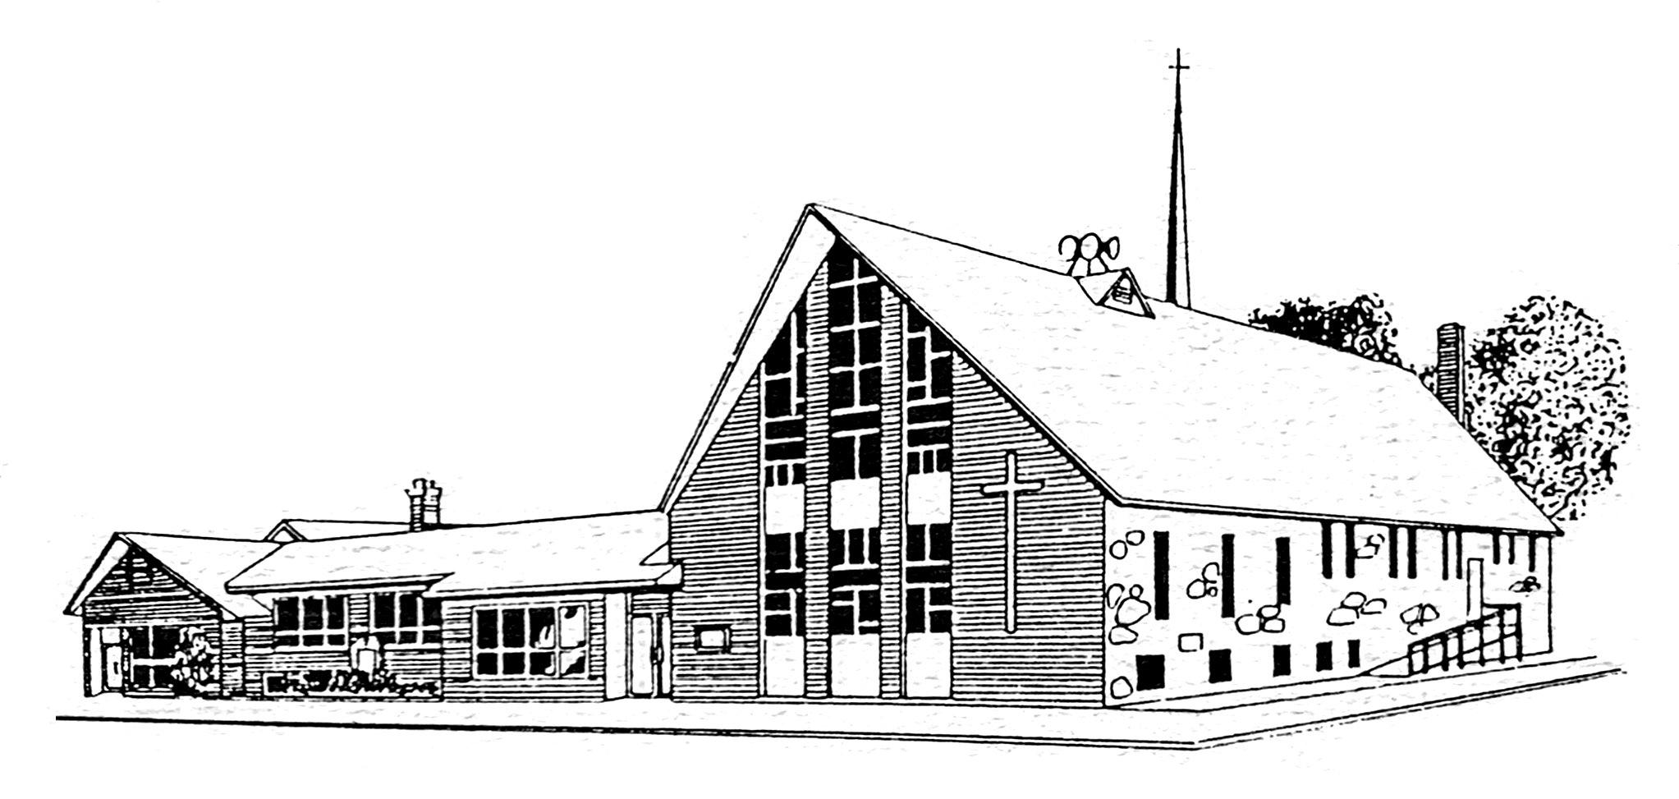
First English
Lutheran Church
July 2023 Newsletter

Lutheran Worship?
Pastor Adam Guthmiller
Worship can sometimes be a strange word. It goes back to the root words of worth and ship – whereas worth is a “condition of being worthy, dignity, glory, distinction, honor, renown,” and ship is a “sense of reverence paid to a supernatural or divine being.” All of this helps color what worship is – and yet this tells us nothing about what makes worship Lutheran, let alone Christian.
The Holy Scriptures are, of course, filled to the brim with stories and examples of people participating in false worship. The most blatant being the people of Israel crafting a golden calf when Moses was delayed from coming down the mountain. They wrongly ascribed to the golden calf what God had done: “These are your gods, O Israel, who brought you up out of the land of Egypt (Exodus 32:4).” They then promptly, “rose up early the next day and offered burnt offerings and brought peace offerings. And the people sat down to eat and drink and rose up to play (Exodus 32:6).” There was worship on that day, but it was false – giving honor, glory, and reverence to that which was not God.
What then makes worship Lutheran then? Martin Luther described worship and the church as the place where, “nothing else need ever happen except that our dear Lord himself may speak to us through his holy Word and we respond to him through prayer and praise (LW 51:333).” You would be wise to notice that there is something absolutely radical here – as the worship which Luther
describes is not primarily an activity understood primarily as being a work of Man.
Lutheran worship has at its foundation the understanding that God in Jesus Christ has come to serve us. Read how the old LCMS hymnal Lutheran Worship puts it:
Our Lord speaks and we listen. His Word bestows what it says. Faith that is born from what is heard acknowledges the gifts received with eager thankfulness and praise… Saying back to Him what He has said to us, we repeat what is most true and sure… The rhythm of our worship is from Him to us, and then from us back to Him. He gives His gifts, and together we receive and extol them. We build one another up as we speak to one another in psalms, hymns, and spiritual songs. Our Lord gives us His body to eat and His blood to drink. Finally His blessing moves us out into our calling, where His gifts have their fruition (Lutheran Worship, 6).
God “calls and gathers (Small Cat. Art. 3)” us by His Holy Spirit so that He could place us in the hands of Jesus Christ by His Word. Lutheran worship makes the distinction between Law and Gospel so that faith in Jesus Christ and His work of salvation for sinners would be created. And it is faith which is the highest worship of God: “Faith is that worship which receives the benefits that God offers (Apology of Augsburg Confession IV, 49).

July Birthdays

1-Konnor Gayle, Zach Jorgensen
2-Ashtyn Gribble, Tenley Sturm
3-Kenna Klinghagen, Scott Timmerman
4-Justine Doud, Lance Gerry, Lexi Severson
5-John Ganschow, Bobby Myers
6-Hannah Bachmann, Joel Brewer, Amber Lounsbery
8-Ryan Luden
9-Jean Reiners
10-Laikyn Fodness, Joshua Schmidt
13-Eleanor Tvedt
14-Patty Klinghagen
16-Lisa Frazeur, AJ Fodness, Karissa Iken, Ivy Parr, Carolyn Randel
17-Isaac Burma
19-Raiden Stenzel
20-Scott Bolte, Benjamin Coffee, Les Hyronimus, Cory Jorgensen, Amanda McKnelly
22-Mildred Aldinger, Teagen Bittinger
23-Craig Schentzel
25-Michelle Vietor, Meghan Waggoner
26-Julie Bosma, Michaela Gayken
27-Nate Kruse, Elizabeth Steever
28-Wayne Fischer, Keegsan Jacobson
29-Ryan Renz, Layton Smith, Ryan Weisenbach
31-Samantha DeJong

July Anniversaries

1-Ben & Erin Crabtree
Casey & Michelle Vietor
2-Steve & Amanda Kruse
3-Jim & Donna VanBockern
Chris & Linda Munce
12-Eric & Haley Holmes
Darin & Krista Musser
13-Jacob & Ashleigh Roemen
18-Roger & Gayle Hanisch
21-Nick & Renae Buehner
22-Justin & Julie Hinker
24-Matt & Amber Larson

Worship Attendance

June 4th—79
June 11th—60
June 18th—72
June 25th—62

Lamplighters

Verlyss Jacobson attended Lamplighters [auxiliary of Union Gospel Mission] at Chancellor Reformed on June 16 at 2pm. Mary Weeldreyer welcomed the group before Karen Westerman accompanied our singing “For the Beauty of the Earth.” Pastor Marc de Waard gave the message using many pairs of his own shoes to emphasize ‘One day these shoes are going to walk all over FOR You!’ You being Jesus.

The May offering was $594. The current balance is $2,335. Ellie reported for the mission. 500 people were served a meal at the block party in June. The Lions Club did mobile eye screening. The mission gave phones and tablets to people who need them for jobs. The day before on revitalization day volunteers planted flowers and trees and painted houses in the area of the mission. 32 extra people [mostly teenagers] were at the mission for a week volunteering.

University of Sioux Falls nursing students are doing internships each Friday this summer. The mission can use shoes to give to people who come with no shoes! There have been 25 baptisms at the missions this year. 12 men are in the discipleship program. Food boxes are given on Tuesdays, Wednesdays, Thursdays from 1-5pm. Amount of food given depends on the number of people in the family, income, and what food is available. They continue to bale rags, dirty and unusable clothing and fabric. The bales are sold.

The love gift was any hygiene item. First English Women [FEW] give $10 a month for a love gift. The September 15 meeting is at Grand Valley Lutheran south of Canton. The mission can use bottled water and hygiene kits during the summer. We were served a choice of many kinds of bars, coffee, iced tea, or water.

Endowment Fund News

The Endowment committee would like to thank the following people for their recent gifts to the Endowment fund.

- Leslie Nelson, Art and Tonya Ringen in memory of Don Anderson.
- Harold and Corleen Timmerman, Leslie Nelson, Art and Tonya Ringen in honor of Dale and Vickie Munce 50th wedding anniversary.
- LarRon Stoffers in memory of Paula.
- Harold and Corleen Timmerman, Art and Tonya Ringen, Jim and Donna Van Bockern, Verlyn and Mary Hofer, David Goeman (former resident of Lennox), in honor of Verlyn and Mary’s 75th wedding anniversary.
- An anonymous gift was also received in March of this year.

The Endowment fund also consists of shares of interest in oil well property in Texas that was gifted to the fund by the estate of Clarence Jensen many years ago. Royalty type income from Finley Resources is received by the Endowment fund throughout the year on a random basis but it is worth mentioning that since January of this year a total of $441.00 has been paid and this money will be part of the yearly disbursement of earnings by the Endowment committee.

Your gift to the Endowment Fund to honor any special occasion such as a birthday, anniversary or as a memorial is a lasting gift that benefits the work of the church for years to come. The Endowment fund supports the work of First English in the areas of mission work, youth activities and capital improvement projects. Your gift is invested and it is the dividends and interest from the invested earnings that is disbursed on a yearly basis. There is an Endowment sign up sheet in the church hallway if you would like your gift noted in the Sunday bulletin. Thank you to all for supporting the Endowment Fund.

In Christ,
Endowment Committee

Campership

There will be $100/child available for kids attending a Christian summer camp while funds are available. Parents need to turn in their paid invoice for reimbursement.

Upcoming Dates to Remember:

July 2nd
8:30 a.m. Worship Service of the Word
10:30 a.m. Community Worship in the Park
12:00 noon Community Dinner in the Park

July 5th
1:00 p.m. Wednesday Bible Study

July 9th
9:30 a.m. Contemporary Worship with Holy Communion
10:30 a.m. Coffee & Fellowship

July 10th
4:30 p.m.-6:30 p.m. Grief Share -
Luther Hall

July 12th
1:00 p.m. Wednesday Bible Study

July 16th
9:30 a.m. Worship Service of the Word
10:30 a.m. Coffee & Fellowship/
Semi-Annual Meeting

July 17th
9:00 a.m.-2:00 p.m. VBS

July 18th
9:00 a.m. - 2:00 p.m. VBS
7:00 p.m. Council Meeting

July 19th
9:00 a.m. - 2:00 p.m. VBS
1:00 p.m. Wednesday Bible Study - Library

July 23rd
9:30 a.m. Worship Service of the Word
10:30 a.m. Coffee & Fellowship

July 24th
4:30 p.m.-6:30 p.m. Grief Share -
Luther Hall

July 26th
1:00 p.m. Wednesday Bible Study
2:00 p.m. Circle Meeting

July 30th
9:30 a.m. Worship Service with Holy Communion
10:30 a.m. Coffee & Fellowship

Financial Information

You may contribute through the mail using your pre-addressed offering envelopes or mail to PO Box 562, Lennox, SD 57039.

Finances

June Offerings: $15,643 was received toward our giving goal of $14,873. Thank you for your generous support of First English Lutheran Church and the proclamation of the Gospel of Jesus Christ.

How to Give!

FELC has the option for you to enroll in a Direct Deposit offering system. You choose how much, which accounts (General or Building), and how often! If you would like to sign-up for this giving option or have any questions, please contact Gayle at office@felclennox.org.

Venmo payments are accepted as well. To utilize Givebutter simply scan the QR Code with your mobile device or type in the link below and it will pull up FELC’s Givebutter campaign. Use any form of payment option: Venmo, PayPal, credit card, debit card, ACH, Apple Pay, Google Pay, and Microsoft Pay. Givebutter does add a 3% processing fee + .30 cents per transaction so that 100% of your donation goes to FELC-Lennox. https://givebutter.com/Lennox-FELC

Study of God’s Word at FELC

Wednesdays at 1:00 p.m. in Luther Hall we have a Bible Study of the Scripture for the upcoming Sunday. Join us to hear God’s Word!

Mission Opportunities

“And you shall love the Lord your God with all your heart and with all your soul and with all your mind and with all your strength.’ 31 The second is this: ‘You shall love your neighbor as yourself.’ There is no other commandment greater than these [Mark 12:30-31].”

Health Ministry

Please prayerfully consider serving on the Health Cabinet. Notify Laurie Wernke or Gayle Hanisch if you would like to join the Health Ministry team or Chair the Meal Ministry team.

Responsibility of a Health Cabinet member is to pray for the Health Ministry, support and encourage the Health Ministry, help to plan and prepare for events developed by the Health Cabinet team. What is my responsibility as a Meal Ministry Chairperson? You would be responsible to help plan cook dates, e-mail ingredients, communicate with the faith community nurse and members of the team and attend the cook dates and oversee meal assembly. Meals are prepared and delivered. Please feel free to deliver a meal to someone in need. A person suffering from illness, hospital stay, homebound or neighbor with a new baby. Please use the meal sign out sheet attached to the freezer door.

Faith Community Nurse News

Grief Share will be July 10th and July 24th the 2nd and 4th Mondays from 4:30-6:30pm with a meal.

Remember to bring Healthy snacks for the Bible school children. Learning to eat healthy is a life-long challenge. Vegetables,
fruits, milk, yogurt, and granola bars.

Summer can be fun but stay safe and look both ways before crossing into the street.
Remember to apply sunscreen before being in the sun for extended periods of time.

Vacation Bible School

VBS will be held at First English for students entering 1st – 6th grades this fall. We invite all to join us. Contact Michelle Vietor with any questions. Registration can be found at: https://forms.gle/FoajEaSHxrtNexGE8.

FEW Guest Night

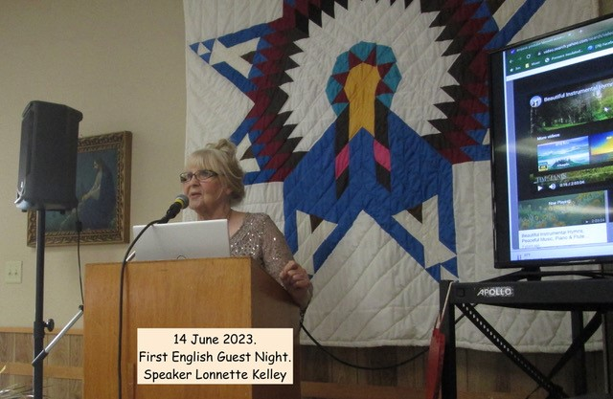

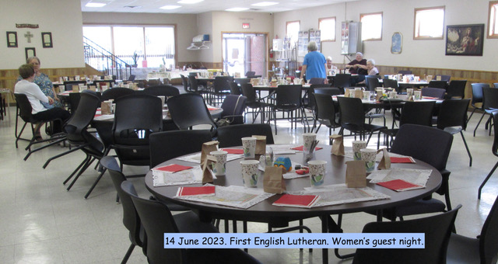
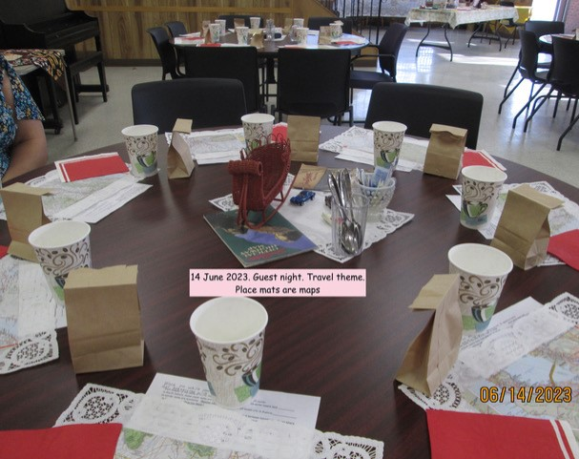

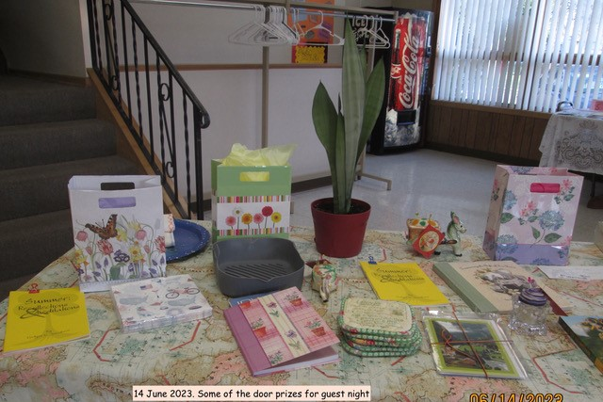

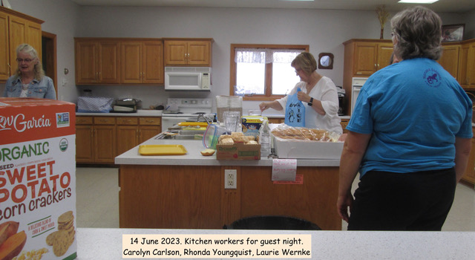

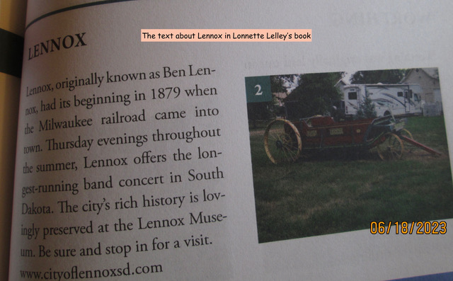
Synopsis of June Council Meeting

1. Call to Order: John Steever, also present; Elizabeth Bachmann, Mike Bosma, Chris Juffer, Byron Youngquist, Pastor Guthmiller
2. Personal Agendas
3. Devotions
4. Visioning: Pastor Guthmiller
5. Prayer for God’s guidance
6. Secretary’s report Motion to approve Mike, second John- approved
7. Old Business
A. Status of Office shelving - still waiting
8. New Business
A. Transfers: Out Austin, Julianna & Emma Langmeier to West Nidaros Lutheran, Crooks: In - Isaac Timmerman & Michaela Timmerman from Brandon Lutheran.
B. LBW Hymnals - Pastor Discussed and tabled
C. Review Lease agreement and usage agreement for approval Tabled
D. Talk about insurance issues with Pastor Guthmiller’s paycheck Tabled
E. The Livestream link is still not on the website ; being addressed
F. Chose MOM for July and August; July - Spirit Camp, August- Lutherans Outdoors; motion by Mike second by Elizabeth, approved
G. Updated Contact Information-Pastor Guthmiller
H. Stewardship - Pastor Guthmiller
9. Reports
A. Treasurer - motion to approve John, second Elizabeth , approved
10. Next Council Meeting July 18th at 7:00 pm
11. Devotions at Next Meeting: Matt/ Mollie
12. Communion Helpers:
June 25th- John; July 9th
Money counters; June 25 John & Chris, July 9th: Elizabeth & Byron, July 16th Mike & Mollie
13. Adjourn motion by John second by Mike, approved
14. Prayer

July Calendar

 |  |  |  |  |  | 1
2 8:30am Worship Service of the Word; 10:30am Worship in the Park; noon Dinner in the Park | 3 | 4 | 5 1:00pm Wednesday Bible Study | 6 | 7 | 8
9 9:30am Contemporary Worship w/Holy Communion; 10:30am Coffee & Fellowship | 10 | 11 | 12 1:00pm Wednesday Bible Study | 13 | 14 | 15
16 9:30am Worship Service of the Word; 10:30am Coffee & Fellowship/  Semi-Annual Meeting | 17  9:00am-  2:00pm VBS | 18 7:00pm Council Meeting  9:00am-  2:00pm VBS | 19 1:00pm Wednesday Bible Study - Library  9:00am-  2:00pm VBS | 20  9:00am-  2:00pm VBS | 21 | 22
23 9:30am Worship Service of the Word;  10:30am Coffee & Fellowship | 24 | 25 | 26 1:00pm Wednesday Bible Study; 2:00pm Circle Meeting | 27 | 28 | 29
30 9:30am Worship Service w/Holy Communion;
10:30am Coffee & Fellowship

